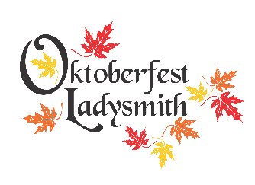
2022 VENDOR LISTING
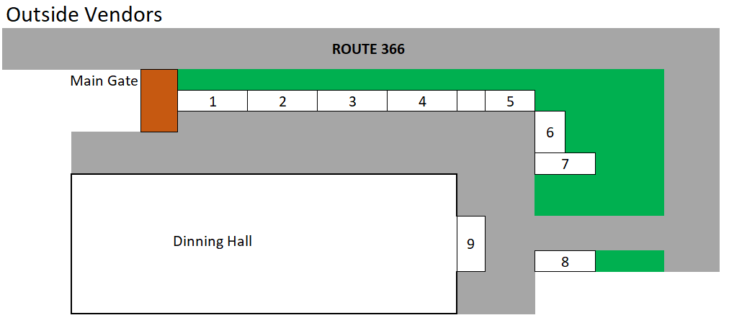
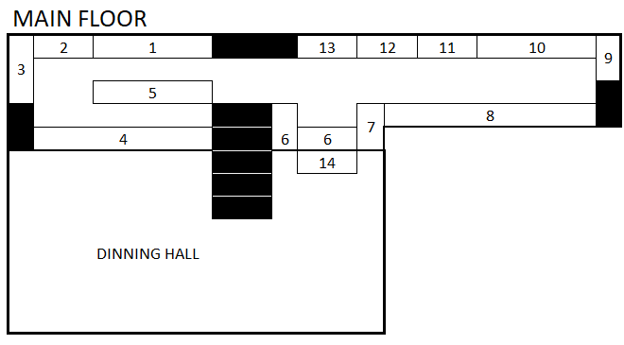
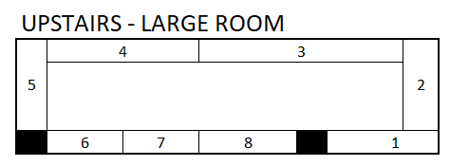
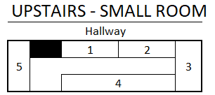
OUTSIDE
1. Les Spurrell Rustic Furniture  Haley Station, ON  TEL: 613-432-3492  DESCRIPTION: Hand made rustic furniture. Specializing in rocking chairs and coffee tables. | 2. Face Painter Lyzzy  Saturday from 10am to 2pm for free face painting..
3. Valley Merchant Outlet  Dunrobin, QC  www.fb.com/valleymerchant  vmo447@hotmail.com  TEL: 613-832-0216  DESCRIPTION: Hand made sweaters, hoodies, mitts, hats and much more! | 4. Tania Marie  Ottawa ON  Sweet Treats Bakery: a variety of cookies, brownies, blondies, and cupcakes.
5. Carolane Gauthier  Duclos, QC  The Wrap Around Shop: Crystals, handmade jewlery and home décor. | 6. Tanya Zadow  Pembroke, ON  Wild Irish Soaps, Handmade soaps, bath bombs, pump soaps, sugar scrubs, etc.
7. Anne Lafontaine  Organic Infusion  The company's product's are developed around two business lines; healthy nutrition based on the infusion of herbal oils and infused herbal and fruit vinegar; skin care , bath and shower product ( from bath bombs to artisan soaps) built from essential oils. | 8. Fellowship of the Christian Farmers  TEL: 819-213-5815  The Fellowship of Christian Farmers will be offering (free) gifts coupled with an explanation of why they must be given without charge (and no future costs either).  L'Assoication des fermiers chrétiens du Canada offrira des cadeaux (gratuits) accompagnés d'une explication de la raison pour laquelle ils doivent être donnés sans frais (et sans coûts futurs non plus).
9.

MAIN FLOOR
1. Darlenes & Marion Dagenais  Luskville, QC  TEL: 819-455-2693  DESCRIPTION: Knitted good (Towels, mitts, scaves, hats, slippers, dishclothes etc). Fall and Christmas centerpieces and decorations. ecorated window shutters, decorated ladders, wooden cardinals for your garden & much more! | 2. Kraften Kustoms  Kristen Woolsey  Luskville, QC  kraftenkustons@outlook.com  TEL : 819-210-9911  DESCRIPTION: 3D wood signs, personalized home decor & gifts
3. Hand Made Quilts  Eileen Dubeau  Otter Lake  TEL: 613-623-7407  DESCRIPTION: Handmade quilts of all kinds! From crib sized to queen sized. Homemade socks and scarves. | 4. C&E Creations  Ernie Wilson  ernie.wilson@sympatico.ca  TEL: 613-646-2712  DESCRIPTION: Assortment of painted metal cans, wood crafts, home and Christmas decor.
5. Erin Dittburner  Shawville | 6. D & E Crafts  Donna Rebertz  Shawville, QC  decrafts@hotmail.com  TEL: 819-648-2836  DESCRIPTION: Sewing, crafts, canning and much more
7. D & E Crafts  Donna Rebertz  Shawville, QC  decrafts@hotmail.com  TEL: 819-648-2836  DESCRIPTION: Sewing, crafts, canning and much more | 8. FanTABulous Designs  Tabetha Robertz  Shawville, QC  fantabulousdesigns2018@hotmail.com  TEL: 819-592-0822  DESCRIPTION: Custom Hand Made Jewelry
9. Rockingham Wilderness  Drenda Lapenski  Wilno, ON  www.rockinghamwilderness.ca  sales@rockinghamwilderness.ca  TEL: 613-757-3298  DESCRIPTION: Camouflage garments for outdoor lovers. Sizes from newborn to Adult XXL. | 10. Lynn Graveline  Campbells Bay, QC  lynnbrown50@hotmail.com  TEL: 819-648-5581  DESCRIPTION: Knitted goods (tuques, scraves, mitts, headbands, swiffer covers ,dish clothes).
11. Colorstreet  Mylene Parent  www.colorstreet.com/myleneparent  DESCRIPTION: Colorstreet offers nail strips made of 100% nail polish. These nail strips are meant to fit your exact nail shape and mimic the appearance of a salon quality manicure without the actual painting of nails. | 12. Tanya Zadow  Pembroke, ON  Wild Irish Soaps, handmade soaps, bath bombs, pump soaps, sugar scrubs, etc.
13. Maggies Jewelry & Accessories  Marg Lewis  Portage-du-Fort, QC  mdlewis26@hotmail.com  TEL: 819-647-6411  DESCRIPTION: Sterling Silver Gemstone & Fashion Jewelry, Ladies winter hats and ponchos. | 14. Independent Watkins Natural Wonders  Patricia Levesque  Otter Lake, QC  https://www.jrwatkins.com/consultant/658324  patricia.levesque@tlb.sympatico.ca  TEL: 819-453-2380  DESCRIPTION: 96-100% Natural Products. Gourmet, Body Care, Home Care & Remedies and the Best Insect Repellent on the Market!

UPSTAIRS LARGE ROOM
1. Craft Table Creations  Sue Nicholas  Arnprior, ON  creationsbysueshands@gmail.com  TEL: 613-623-6808  DESCRIPTION: Knitted hats, scraves, custom tuques, dishclothes, quilts, slippers. Assorted sewing items and crafts. | 2. Craft Table Creations  Sue Nicholas  Arnprior, ON  creationsbysueshands@gmail.com  TEL: 613-623-6808  DESCRIPTION: Knitted hats, scraves, custom tuques, dishclothes, quilts, slippers. Assorted sewing items and crafts.
3. Nells Dazzling Jewels  Nelly Sawatzky  Ottawa, ON  nellysawatzky@yahoo.com  TEL: 613-825-0727  DESCRIPTION: Jewelry | 4. One Stitch at a Time  Lynn Rosien  Carleton Place, ON  larosien@hotmail.com  TEL: 613-621-1966  DESCRIPTION: Jams. Knitting of all kinds (Socks, slippers, mittens, dishclothes, towels, baby slippers, scrubbies and more!)
5. Kim McDougall  Kim McDougall writes Urban Fantacy fiction and , writing s KimChatel, picture books for kids. SHe illustrated her first picture book, Rainboe Sheep with fibre art and brings her books and needle-felted ornaments for sale. Visit Kim online at https://kimmcdougall.com and http://www.kimchatel.com | 6. Country Creations and Crafts  Lori Sheppard  Shawville, QC  www.fb.com/countrycreationsandcrafts  lori.sheppard@live.com  TEL: 819-647-4710  DESCRIPTION: Home decor sales
7. Sharianne Salzer  handmade mittens and hats from recycled wool sweaters, she is from Glocester and contact info shari-anne@hotmail.com | 8. Lisa Boivert  Tupperware Rep
UPSTAIRS SMALL ROOM
1. Knot Firewood  Karen Davies  Otter Lake, QC  harried_mom@hotmail.com  TEL: 819-665-0413  DESCRIPTION: Knot wood creations | 2. Knot Firewood  Karen Davies  Otter Lake, QC  harried_mom@hotmail.com  TEL: 819-665-0413  DESCRIPTION: Knot wood creations
3. Satura Bath & Body  Amanda McLeese  DESCRIPTION: Crafted skincare and wellness brand. Sugar scrub, body butter, foot scrub, etc. | 4. Trish White  Shawville, QC  Epicure
5. Erin’s Creations
Erin Tubman
Erin.staubin84@gmail.com
TEL: 514-945-0973
DESCRIPTION: String art, decorative signs, creations.

